Information from website “The School Run”
Links will not work because this is copied across but you can look them out.

Titanic
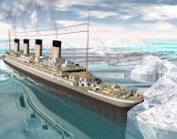
The Titanic is probably the most famous ship ever to have been built. At the time it was launched, it was the biggest ship in the world.
The huge ship was said to be the biggest, the best and the safest ship ever to have set sail. But on 15 April 1912, five days into its very first voyage from Southampton to New York, the Titanic collided with an iceberg and sank. There were over 2200 people on board but only 715 people survived.
The wreck of the Titanic was discovered 74 years later, just over 2 miles under the sea.

Top 10 facts
1. Building on the Titanic began on 31 March 1909; it was finished three years later.
2. The Titanic was built in Belfast, Northern Ireland.
3. The Titanic’s official name was the RMS Titanic (RMS stood for Royal Mail Steamer).
4. In 1912 the Titanic was the largest man-made moveable object ever built.
5. The famous ship was 92.5 feet wide, 175 feet high and 882 feet long – bigger than 3 football fields put together!
6. A huge ship requires a lot of staff – the Titanic had a crew of around 900 people!
7. On its maiden voyage, the Titanic collided with an iceberg and sank on April 15, 1912. Over 1500 people died.
8. The Titanic was a luxury passenger liner that carried some of world’s richest people.
9. The first voyage the famous ship was due to take was from Southampton to New York.
10. The Titanic left Southampton on April 10, 1912 and stopped in France and Ireland before heading west to New York.
- 29 July 1908
The design for the Titanic is approved
- 31 March 1909
Building on the Titanic begins
- 31 May 1911
The hull of the Titanic is successfully launched
- 31 March 1912
The Titanic is completed
- 3 April 1912
The Titanic arrives in Southampton
- 10 April 1912
The Titanic begins her maiden voyage
- 11 April 1912
The Titanic reaches Queenstown, Ireland
- 14 April 1912
The Titanic hits an iceberg. In the early hours of 15 April the huge ship sinks into the sea.

Did you know?
The Titanic was on its ‘maiden voyage’, or first voyage, when it sank.
The ship was built to carry about 3,500 people.
To travel first class on the Titanic would have set you back £875 – but for those travelling third class, it was about £20!
Many of those travelling third class were families who were trying to set up a new life for themselves in America.
The boat sailed from Southampton for its first voyage with 2,223 people on board (1,324 were passengers and 885 were crew). Although there were over 2200 people on board, there were only enough lifeboats for just over half of them.
The boat hit an iceberg off the coast of Newfoundland late at night on April 14, 1912, and sank in the early hours of April 15. Over 1500 people died; only 715 people survived.
The engineers who designed the Titanic thought it was ‘unsinkable’ because it had fifteen separate, water-tight hulls.
The Captain of the famous Titanic was Edward John Smith. He was a proud man and didn’t even attempt to leave the sinking ship.
There was a band on board and some survivors reported that the band carried on playing music while the ship was sinking. Sadly none of the band members were lucky enough to survive.
The boat sank at a speed of 10 miles per hour, taking just 15 minutes for it to reach the bottom of the ocean.
The wreck of the Titanic wasn’t discovered for 74 years, when it was found just over 2 miles under the sea. The ship was discovered in 1985 by an American oceanographer, Robert Ballard, and his team of scientists. So far about 6,000 artefacts have been recovered from the wreck.
In 1997 the film Titanic hit our screens and was a box office smash – it remained the highest-grossing film of all time until 2010, when it was overtaken by Avatar!

Browse through the gallery below to see:
- The Titanic
- Titanic Belfast museum

Gallery
- 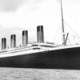
- 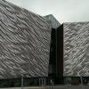

About
The Titanic was, and probably still is, the most famous ship ever to have been built.
It was built by the White Star Line company, which was owned by a rich American businessman called J.P.Morgan, and was thought to be ‘practically unsinkable’.
It cost a massive $7.5 million dollars (about £5.2 million) and was the largest passenger steamship ever built. It took 3,000 men three years to build!
Life on the big ship certainly promised to be plush if you could afford it! Those travelling first class could while away the hours between the swimming pool, gymnasium, squash racquet court and Turkish baths. Second-class passengers could get involved in deck games and board games like chess and backgammon. But those in the third-class quarters weren’t offered such luxuries!
The RMS Titanic finally set off for its maiden voyage from Southampton, England, on 10 April 1912.
The Titanic cost a fortune to run. It burned around 600 tonnes of coal a day, shovelled into its furnaces by a team of 176 men.
It was well stocked with food and drink too! Every 24 hours, 14,000 gallons of drinking water were consumed. There were 20,000 bottles of beer on board, 1,500 bottles of wine and 8,000 cigars – all for the first-class guests of course. Before the fatal collision, the first-class passengers were served a supper consisting of an incredible 11 courses!
During the ship’s short journey, they received six iceberg warnings, but the fatal sighting of an iceberg came on the night of 14 April 1912. The ship was ordered to turn but it was too big to do so in time and at 11.40pm the ship struck the iceberg. Just three hours later, the huge ship sunk completely.
The Titanic was so big, she couldn’t change direction quickly enough. She scraped along the iceberg's side, tearing holes in at least four sections of the hull!
In the chaos, many of the lifeboats went out with only a few passengers in them. The fact was there weren’t enough lifeboats for the amount of passengers on board. There were only 16 wooden lifeboats and four collapsible boats, enough to carry 1,178 people, only a third of the Titanic’s total capacity – amazingly that was still more than was legally required.
Just over 1500 people died in the tragedy, with only 715 survivors. Amongst the survivors were two of the nine dogs on board – a Pomeranian and a Pekinese.
The Titanic sank at night, so the sky would have been pitch black and the water was freezing (-2 degrees Celsius). Many people would have died from the shock of the cold within minutes.
At the time of the Titanic, there was a sea law that said women and children needed to be rescued first. This explains why most of the people who died were men.
Millvina Dean was the last remaining survivor of the Titanic. She was only two months old when she joined the ship on its maiden voyage. She died on May 31, 2009, aged 97.

Related Videos
- Have to see on The School Run website

Just for fun...
Would you have survived the sinking of the Titanic? Find out with National Geographic Kids.
Colour in and complete Titanic colouring pages
A Titanic video game will allow users to explore a complete and fully interactive recreation of the most famous ship in history; you can preview it on the Titanic: Honor and Glory website
Examine some of the Titanic passenger lists to find out more about the people who sailed on her

Children's books about Titanic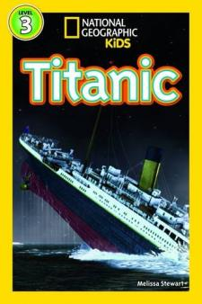 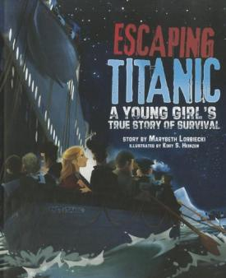 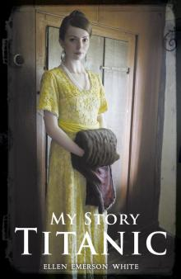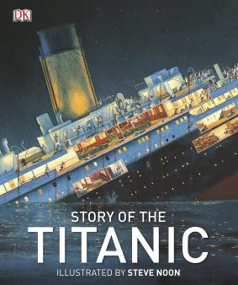 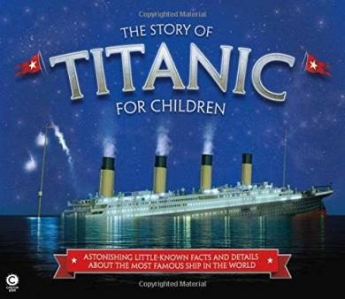 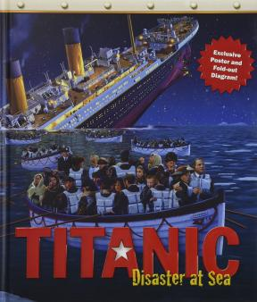 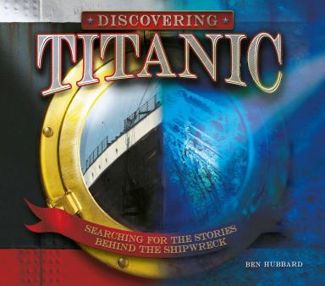

Find out more
Read the BBC Bitesize guides and watch animations about the sinking of the Titanic: Titanic facts and figures, what life was like in Belfast in 1910, how the Titanic was built and life on board the Titanic
Watch an introductory animation about the Titanic
A detailed, labelled picture of the Titanic
Discover more about the rise and fall of the Titanic
The Kiddle Encyclopedia entry about the Titanic
Look through the CBBC Newsround timeline of the Titanic sinking
See images of some of the items recovered from the Titanic or belonging to survivors
Watch a BBC animation about the different passengers who traveled on Titanic
Look at a picture of a life vest from Titanic
See a Titanic image gallery, listen to audio recordings of the experiences of some Titanic’s passengers and crew and look at hundreds of artefacts on the Titanic website from National Museums Northern Ireland
Explore the social class of some of the passengers on board Titanic with a downloadable fact pack with details of three of Titanic’s survivors, Lady Duff-Gordon, a first-class passenger; Elsie Doling, a second-class passenger and Rosa Abbot, a third-class passenger
Look through a gallery of images of the Titanic wreck under the sea
Read the stories of witnesses, victims and survivors of the sinking of RMS Titanic
An animation about Eva Hart, a child survivor of the Titanic

See for yourself
Find out all about the Titanic in Belfast, where the ship was built and launched; our review of Titanic Belfast Museum tells you what's on offer for parents and children
See photographs taken during the Titanic’s voyage from Southampton to Cobh (Queenstown) in Ireland
At SeaCity Museum experience Southampton's Titanic story
See the only known surviving first-class ticket for the Titanic at the Maritime Archives and Library in Liverpool
Free events, talks, craft sessions and performances about the Titanic take place at the Merseyside Maritime Museum, Liverpool. Find out how the Titanic story is linked to Liverpool in a special exhibition, Titanic and Liverpool: the untold story

