5. Try-day Friday
Friday – the start of the weekend and sometimes we see it as the time to ‘relax’ when it comes to healthy habits.
Why not make Friday a ‘try day’. Try a new healthy habit. Chat with the family and see what works best. See the list below for a few ideas but feel free to add more!

New Food: It could be trying a different food –fruit/veg or a whole meal option. Perhaps a family come dine with me? Can you give it marks out of 10? Don’t worry if you don’t like it, the important thing is to try.

New Exercise: What about a new form of exercise? Cosmic Kids yoga, go noodle, Joe Wicks, the list is potentially endless for ideas indoors. If you would rather stay away from the screen: Make up an obstacle course – indoors or outdoors, make your own ‘circuit’. Could you go for a walk/cycle together? If you want to make the walk a bit more interesting could you do a scavenger hunt?
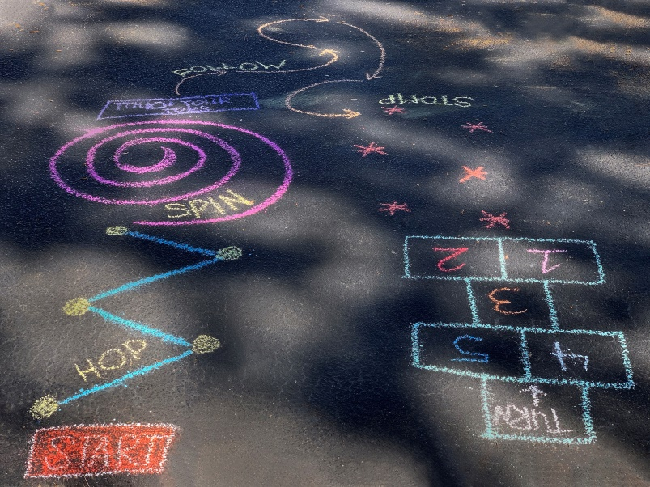


Tech Free night: Try to have some fun as a family without technology – try a board game or a DIY game – see The chocolate game or Goldfish bowl as a starter? Play card games, charades anything that doesn’t involve technology. But everyone agrees to it! Put phones/tablets etc. in a different room and see what you can come up with.


Bedtime routine? Do you struggle to get up in the morning, do you binge watch TV at the weekend, why not try a change, you might not have the same time pressure on a Saturday morning but why not adopt a healthy habit when it comes to bed time. Look at the health and wellbeing section for a few ideas.


Are there any other things you want to try? Remember habits take time to form, this is simply a place to start.

