4. Try Healthy Snacks
At the current time it is so easy to resort to high fat, high sugar snacks e.g. crisps, chocolate etc. We are much closer to the kitchen all day and therefore the temptation is high. Try to think of a few healthy snack ideas in advance so that these are just as handy as the other stuff.
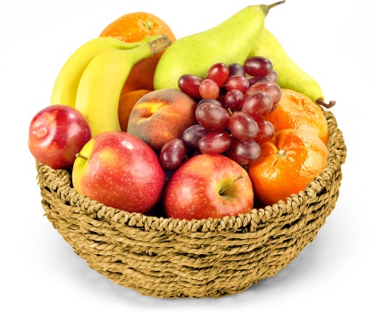
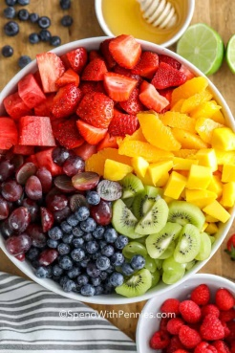
Fruit – Eat the rainbow! If any food needs chopped try to do this early in the day or possibly even the night before. Put it in a Tupperware container so it is ready to go.

VS.

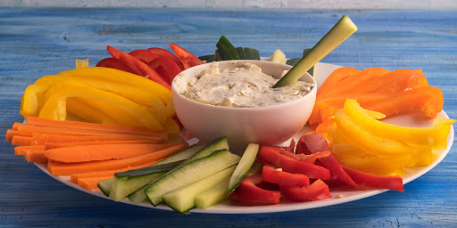
Vegetable sticks and hummus – Sugarsnap peas, peppers, cucumber, celery, carrot are all great options. Chop in advance if needed. Place a damp piece of kitchen roll over the top to keep them from drying out!

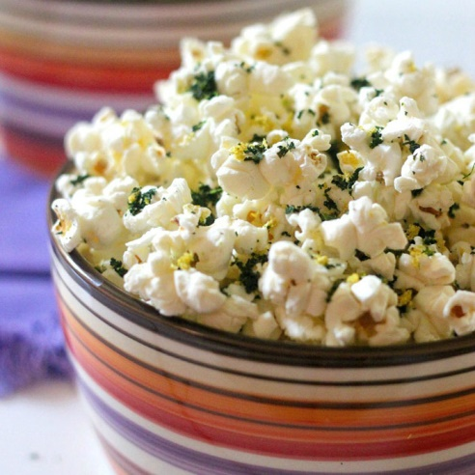
Popcorn – not the cinema type! Popcorn can be a really healthy snack and there are lots of different options. Herbs and spices can be used for lots of savoury options – a tiny drizzle of oil will help spices to stick. Cinnamon and honey may be a nice sweet alternative. (only a tiny bit of honey is needed)

Crackers and Cheese: Try oatcakes/rice cakes etc and a small amount of cheese as an alternative to crisps.
For more ideas have a look at the links below:
https://www.safefood.eu/Recipes/Snacks.aspx
https://www.nhs.uk/change4life/food-facts/healthier-snacks-for-kids/100-calorie-snacks
https://www.nhs.uk/live-well/eat-well/surprising-100-calorie-snacks/
Treats: Keep a treat as a treat not an everyday food! It’s OK to say no! If they are become too frequent then they are no longer a ‘treat’ but part of our daily diet and add very little nutritional value.

