Surviving Summer
Summer 2020! A summer unlike any we have known before. You may have just about got into a routine with schoolwork etc. and now we have summer – usually a time for holidays, lots of playing with friends, going to the beach etc. But this year things look a bit different so I wanted to offer a summer survival guide.
A few pointers:
- Routine: I know the holidays might usually be a time to go with the flow but with so much out of our control at the moment a flexible routine might help everyone. E.g. get outside in the morning, do an activity in the afternoon – see below for suggestions.
- Make some great memories: The ideas below are suggestions, you might have more of your own but use this time to have some fun and try new things when we don’t have to rush off anywhere. Take photos and maybe at the end of summer you could make a scrapbook of all the things you did.
- Themed week: If your kids have previously gone to a summer scheme each year why not do your own and pick your own theme e.g. superheroes, jungle explorers, under the sea etc. Then anything you do that week could be with that theme in mind
- It is OK for kids to be bored occasionally! Boredom is a great kick start for creative ideas!
- Play with them – embrace your inner child – if you get stuck in with games and activities then it is likely they will too!
- Sensory/Messy Play – Not just for little kids! Children of all ages can enjoy the sensory play ideas, if you have older children they might like to get involved with making for younger siblings. These can be really good ways for everyone to calm down if having a tough day. I love the cloud dough!
- Back to school: We hope that by August we should have a much clearer picture of what school will look like – try to start talking positively about school a few weeks before they are due to return. If children get anxious by direct conversation then maybe use a sensory activity e.g. play dough to focus on and conversation may happen during play.
Behaviour Changes: As restrictions start to ease you may find that kids also change their behaviour – some will find that after weeks of not being able to see anyone getting to a shop or visiting a relative may feel like a huge deal and react differently than you would expect. Lots of time to play/craft/create may help them express how they are feeling and hopefully prevent too much destructive or challenging behaviour. Some younger children may act out COVID-19 scenarios or there could be lots of talk about doctors and nurses. Let them talk about how they are feeling. Remember all feelings are valid but not all behaviour is!

8 weeks of summer x 5 weekdays/week = 40 days of activities!
 | Week 1 | Week 2 | Week 3 | Week 4 | Week 5 | Week 6 | Week 7 | Week 8
Monday | Grow your own from scraps: see instructions below. | Alphabet Scavenger hunt indoors: Write out the alphabet on paper/post its – can you find 1 household item for each letter e.g. a = apple, B = book, C = CD etc. | Fizzy ice cubes:  See below | Bake: something new: let the kids scour the recipe books/magazines or google a recipe. | Giant name Art: Can you write their name in big bubble letters = decorate with paint/pens/stickers or use some leaves/flowers etc. You can use baking paper/cardboard etc. to write on. | Kitchen utensil bubble wands: see below | Make a stick person family – Gather sticks when out walking and then use string to bind them together – you can add clothes too! | Box road/Town – Do you have a large cardboard box – open it out and draw a road on it, can you build around it – you could use Jenga blocks, lego, duplo etc.
Tuesday | Outdoor Obstacle course | Recycle + upcycle = Have a look at your recycling – what can you make? | Make a lava lamp at home – see instructions below | Tell a story – use your favourite character or toy animals/ action figures. Make your own adventure! | Build a fort/cave outdoors – lots of inspiration in the World Around Us Parent Booklets | Muddy Toy wash – see below | Make Binoculars – save 2 cardboard tubes – tie/glue them together and decorate | Marshmallow /Spagetti tower – who can build the tallest structure?
Wednesday | Scavenger hunt – outdoors – see World Around us Section of School website for ideas | DIY water table outside – washing up basin + whatever plastic cups/jugs you might have. | Make Foam – see below | Board game marathon - Take it outdoors if it is a nice day – see our parent booklet 2 in the World around us section. | Make salt dough shapes – See our art section of the school website | Make a water filter – see the world around us – Parent Booklet 2 for instructions. | Bubble art – see art section of the school website. | Treasure hunt indoors – do you have any small toy figures/animals? Wrap in tinfoil and hide all over the house!
Thursday | Make Play Doh – See below | Teddy Bears picnic – indoors or out depending on the weather | Chalk painting – great for outside – washes off easily. See below | Make a dinasour using pasta or paper plates – see our Art section of the school website. | Cook a new meal – raid the recipe books and try something different | Vegetable painting – see below. | Create a reading nook/cosy corner as a little retreat. | Make Cloud Dough – see below for ideas.
Friday | Movie Night | Come dine with me – either in teams or as individuals prepare some food and score! | Snowball fight – make snowballs out of paper/newspaper etc. Create a dividing line down the centre. Set the timer and whoever has the least snowballs at the end is the winner | Retro Movie night – get the adult to select their favourite childhood movie | Play Charades | Card Game marathon – how many games can you remember?  Jack Change it, Rummy, Snap,etc. | Balloon Tennis – Make a racquet by attaching a paper plate to a stick. Have a line in the middle that separates the court – see who can keep the balloon in the air the best | Make a scrapbook of your summer/time in lockdown.

Activity Details
Grow your own From Scraps:
- Carrot Tops: Place carrot top in a bowl of shallow water cut side down. Change water daily and leave in a warm place. When shoots appear you can re plant
- Basil/Corriander/Mint – Place Stems in jar of water with a few leaves still attached. Place in a warm area and change water every other day. When stems have grown plenty of roots re plant them in a container with soil.
- Spring onion/Leek: Place the bulp part in a jar of water, change every day and leave in a warm place. When the green stems start to grow a few inches you can replant.
Homemade Lava Lamp
- Find an empty clear plastic bottle
- Fill about ¼ with oil
- Fill up to near full with some coloured water
- When the oil/water separate, drop in a fizzing tablet (e.g. alka seltzer). You may want to start with ½ a tablet initially. Keep tablets out of reach of children when not doing this.
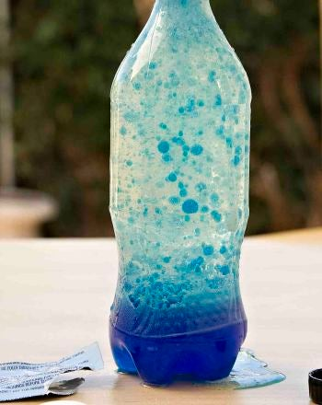
- Watch the reaction! The reaction will continue if more tablet is added. If you make multiple bottles of different colours, can you see what happens if you combine them?

Muddy Toy Wash (kids of all ages seem to enjoy!)
Equipment : Large bowl/basin + a large spoon
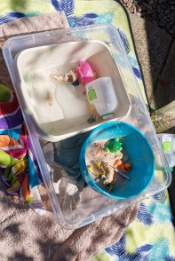
‘Mud’ = 2-4 Tbsp flour, 1-2 tbsp Coco/hot chocolate powder + Water. Add water in small amounts at a time. Mix the ingredients to your desired consistency/thickness. Add whichever toys you choose. Have a 2nd bowl/basin nearby with soapy water to wash the mud off. If it is a good day this is a great activity outside!
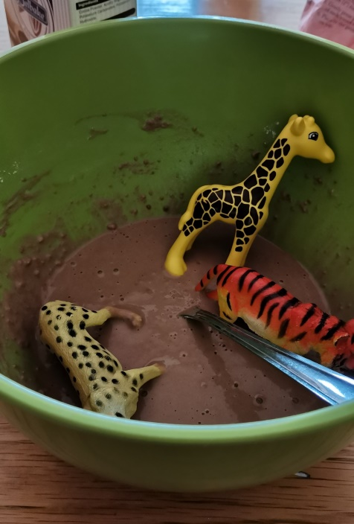
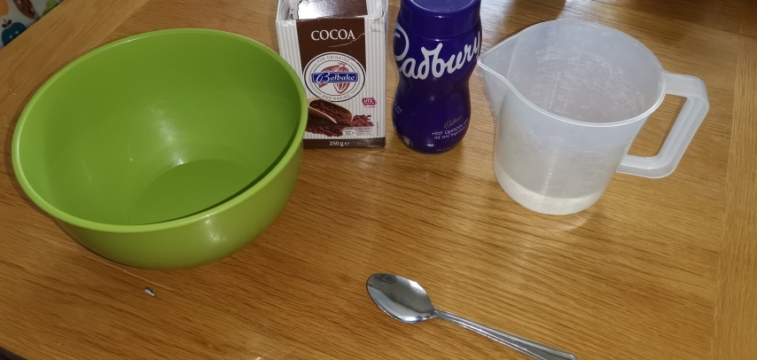

Foam Wash : Great sensory play for all ages!
- 1/2 cup water + Food colouring of choice + Bubble bath (3-4 TBSP should be enough)
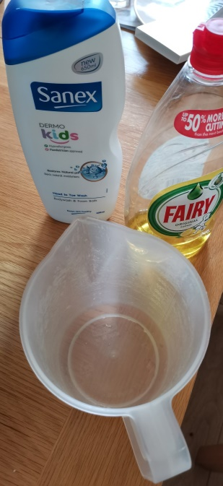
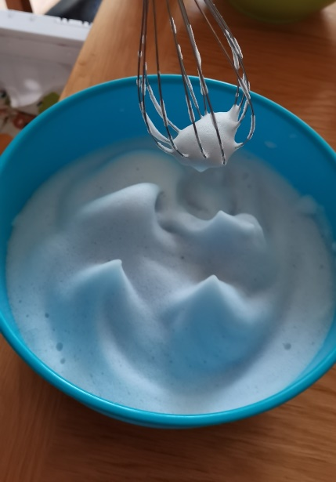
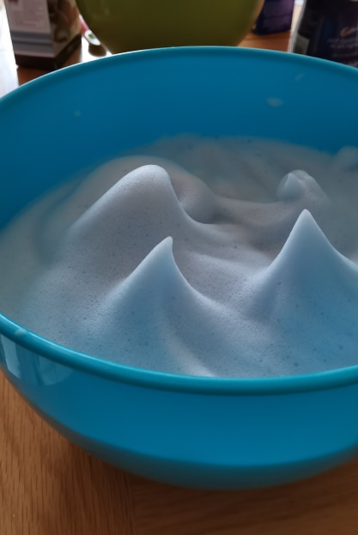
- Mix all ingredients together using hand blender for a couple of minutes until really foamy. Add some utensils/cups or toys and enjoy!
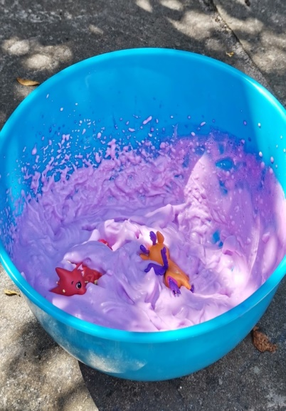
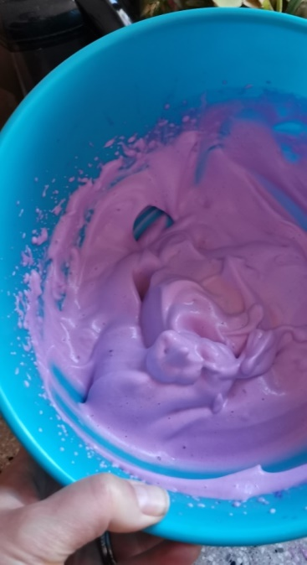

Taste Safe Foam Wash (pink pictures): If you have young children around who like to put things in their mouth you can do a taste safe version using chickpea juice.
- Save the juice from a can of chickpeas + 1tbsp cream of tartar
- Food Colouring/Essence (Optional to give it a nicer smell)
- Use a hand blender to whisk until foam like – this takes about 3/4minutes

Play Dough Recipe (I know we can buy this but the homemade version is sooo much softer to play with!) If you want to watch a video of it made go to www.theimaginationtree.com – there are 50 different combinations here including mint choc chip!
- 2 Cups Plain flour
- ½ cup of salt
- 2Tbsp oil
- 2 TBSP Cream of tartar
- 1-1.5 cups boiling water
- Food Colouring
- Glycerine (This is optional for extra shine so don’t worry if you don’t have/can’t get)
Mix the flour, salt, cream of Tartar and oil together.
Add food colouring to the hot water and then add slowly to the dry ingredients. Mix all together, add a drop or 2 of glycerine if using. It may be slightly sticky to begin with but once you start mixing it this quickly disappears and you have lovely soft play dough. If you want to give it a nice smell you could add food essence/lemon juice/orange rind or some herbs. Once you finish using store in Tupperware and it should keep for about 6 months.
Cloud Dough
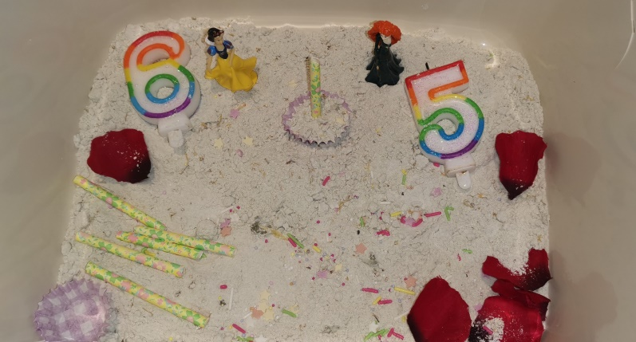
4 cups flour + ½ cup oil = Voila! Mix together – it has a lovely silky texture. If you have any herbs/loose leaf tea, these could be mixed through to add a nice scent.
It will hold its shape if you press anything into it! Use whatever utensils you may have to hand and get creative!

Kitchen Bubble Wands
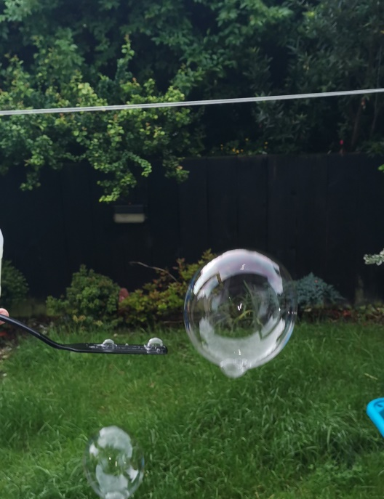
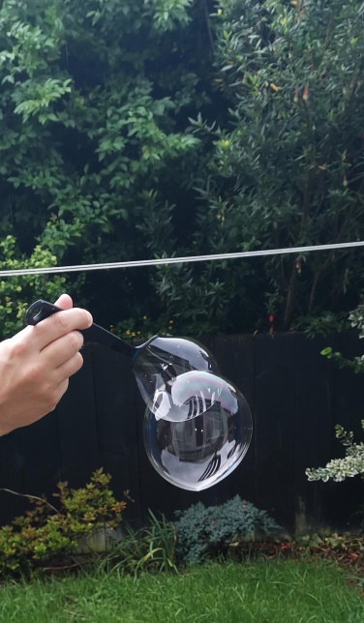
I used an old milk carton as our container. Cut a wider opening at the top and mix a few glugs of dishwashing liquid with water and cornflour. Stir well so that the cornflour doesn’t just sink to the bottom. Leave the mixture for at least an hour and let the bubbles disappear at the top. It is now good for using. Slatted spoons work well as do spatulas but any utensil with a hole should work. Enjoy! Don’t worry if you can’t use all the mixture in one go. It will keep for as long as you need it.
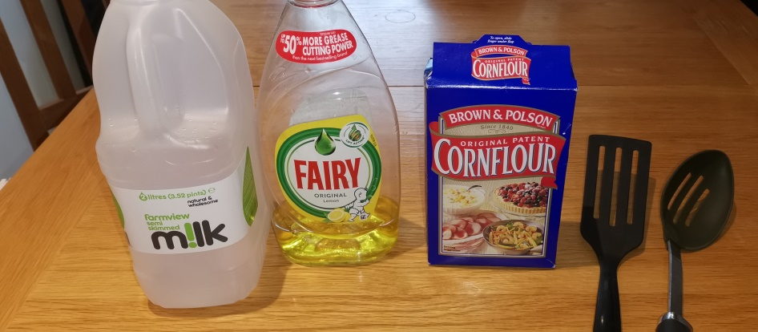

Fizzy Ice Cubes
1 cup bicarbonate soda (baking soda)
½ Cup Water
Mix together to form a paste. Pour into moulds/ice cube trays. Freeze for several hours or overnight. Pour white vinegar over the shapes and watch the fizzy reaction. You can add food colouring if you like. This is a good pre bath time activity if you want to minimise clean up. Everything washes easily away.
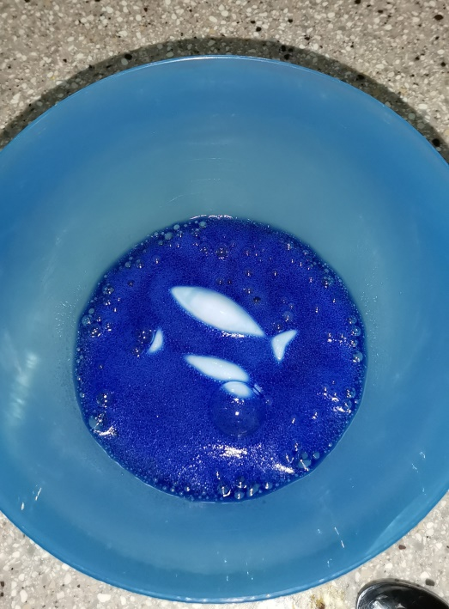
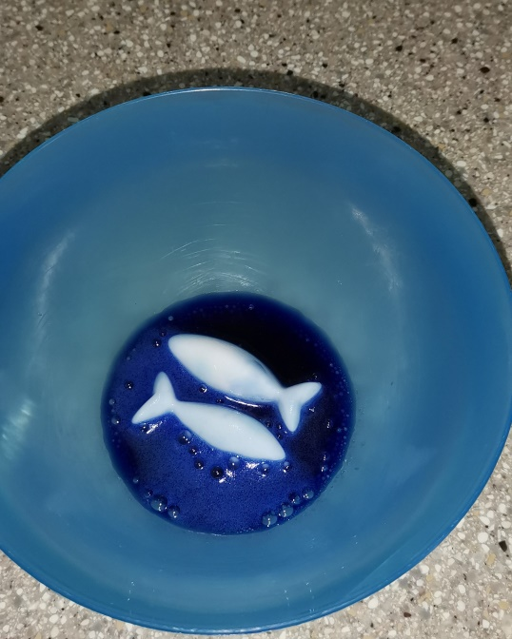
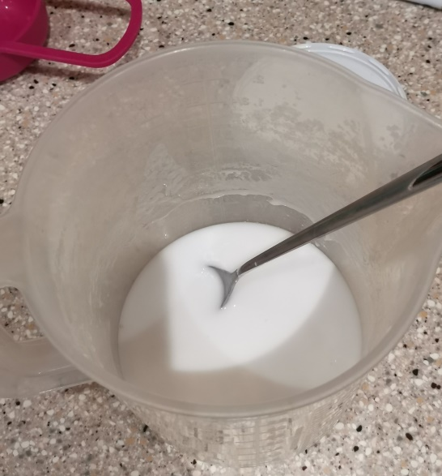
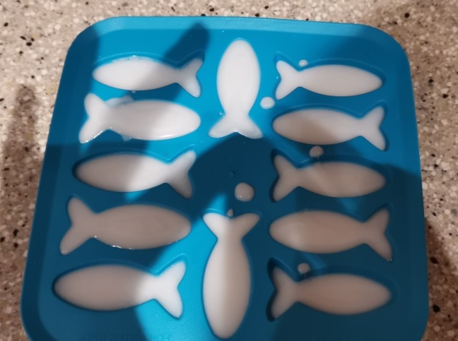

Chalk Paint
Great for using up old broken chalk!
- Crush chalk - putting in a sandwhich bag and using a rolling pin.
- Put the chalk into a separate container/cup and add water- mix until you get a paste – there will still be a few lumpy bits of chalk, it’s OK.

This does work on paper but really good for painting stones outside and washes away easily!
Vegetable Painting
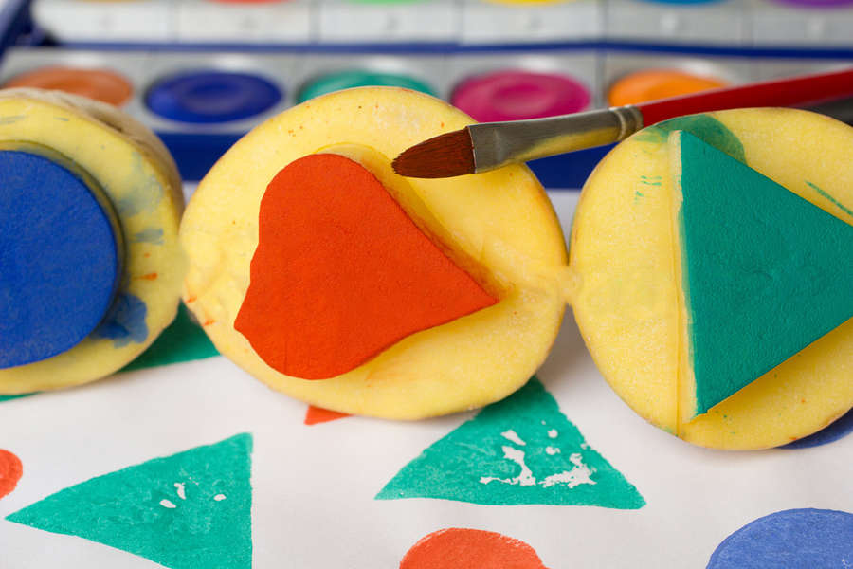
Celery/Pak Choi – use the bottom to create perfect rose shapes
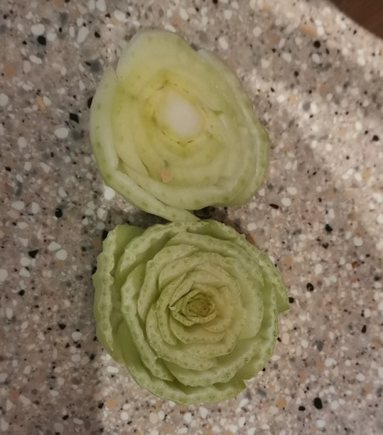

Potato printing: Anyone else remember doing this as a child? It is also a great way to use up potatoes that may be past use in cooking. If you have cookie cutters in different shapes these can be used but don’t worry if you don’t have any.
Cut the potato in half. Draw the shape on with pen, use a knife to score the outside of the shape you want – if you haven’t made these before go for easy shapes e.g. square or triangle. Once you have the shape then cut into the edge of the potato approx. 1-2 cm down from your shape. Peel away the extra potato and you will be left with your shape at the top. For an easy video go to https://www.bbc.co.uk/cbeebies/makes/mrbloom-potatoprint

