
Adding a single digit to a
2-digit number
Spin the spinner to find out the 2 digit number numberhttps://wordwall.net/resource/43862/maths/two-digit-number-wheel
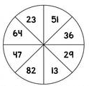

3

+ =

+ =

1

+ =

5


+ =

2

+ =

4

