
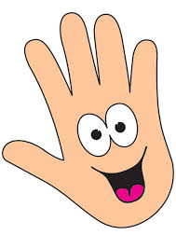
shortest
longer
longest
shorter
Object | My  handspan | Adult handspan
Example  Television | 10 | 7

Measure objects around your house using your hands. Make sure you don’t leave any gaps between your hands when measuring. Now get an adult to measure the same objects with their hands. Did you get the same answers?

e.g. The television is shorter than the rug.

The ____________ is shorter than the ____________.

The ____________ is longer than the ____________.

