
Fairyland Menu

Cake……………………………….40p…

Apple…………………………….20p……………………
Sandwich………………………50p

Chocolate Biscuit…………….10p

Orange Juice…………………30p

Milk………………………………40p

Banana…………………………20p
Order
+ =

+ =

+ =

Example Order
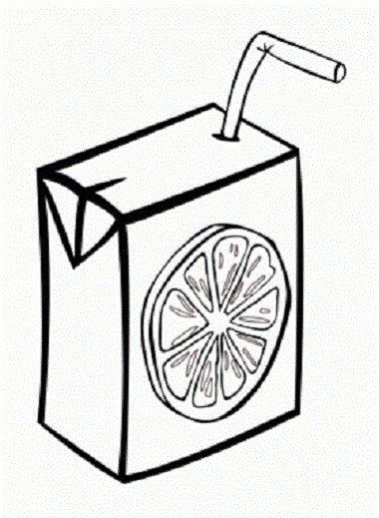


20p + 30p = 50p


