
Subtracting over the ten
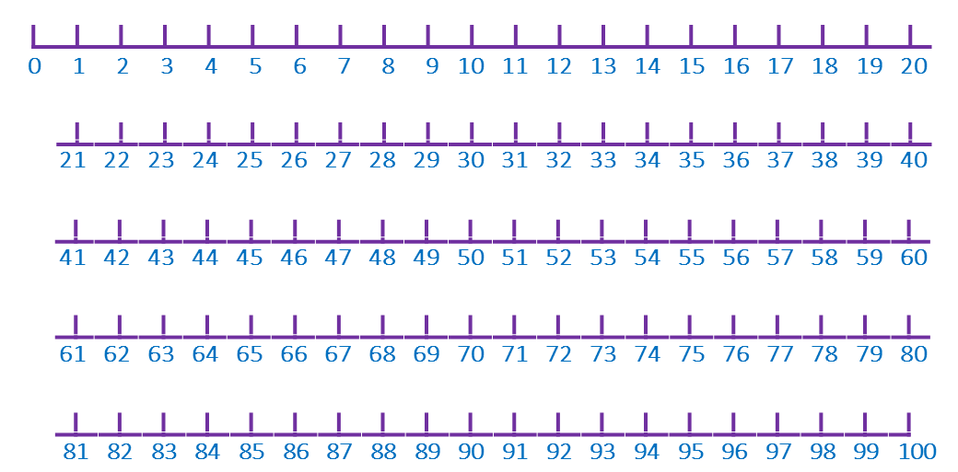

52 – 3 = 33 – 3 =

31 – 2 = 22 – 4 =

80 – 5 = 90 – 2 =

23 – 3 = 45 – 6 =

71 – 4 = 64 – 5 =

