We are going to build some words today using sounds. You will need 10 bits of paper or card. Write one of these letters/sounds on each bit of paper or card.

a t r c i n b p h m
Can you choose the sounds to build these word?

-  ___ ___ ___ 5. ___ ___ ___

-  ___ ___ ___
6. 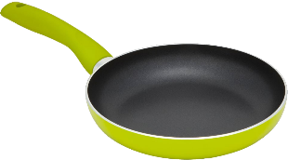___ ___ ___

-  ___ ___ ___
7.  ___ ___ ___
-    

