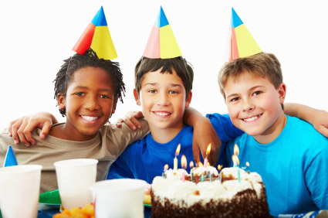

Read this story. Remember, if you are stuck on a word, look at the first sound…and the picture!!

Look at Tom.
Tom is happy.
It is Tom’s birthday.
He is 7.
Look at the cake.
The cake is for Tom and his friends.

Now draw the present  you would get Tom!!

