There are a lot of letters in our world. Each letter has its own sound. If we know these sounds, then we can put them together and work out how to say words. Then we can read!!


Match each letter to the picture that starts with that sound!

 S

 W

 B
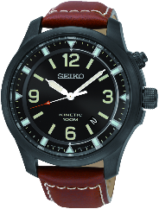 F

