Here is today’s story! Remember what to do if you are stuck on a word! Say the first sound. Look at the picture for a clue. Think about a word that would make sense!

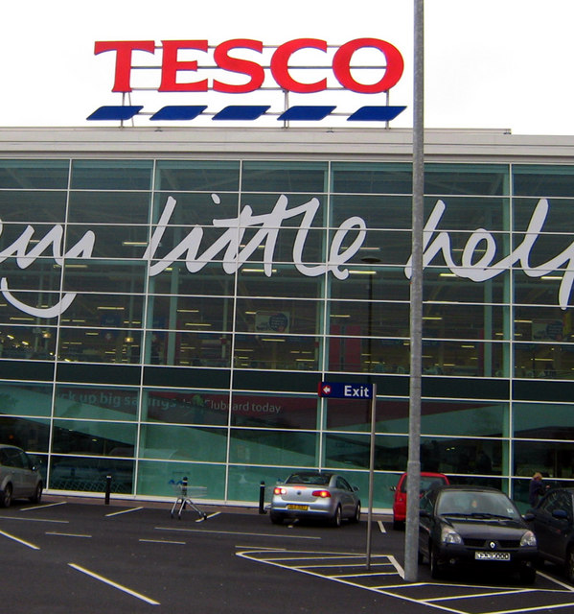

I can see Tesco’s.
I go to Tesco with my mum.
We get some beans . 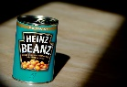
We get some burgers.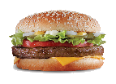
We get some chips.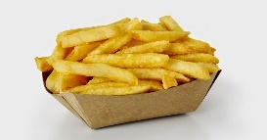
I like Tesco’s!!

