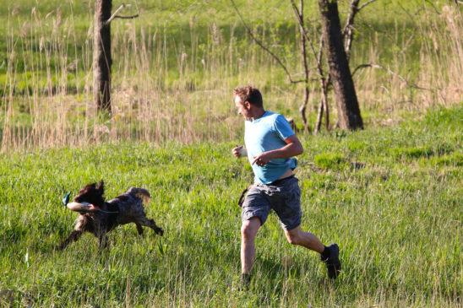
A story for you to read. Look at the first sound if you are stuck on a word!!

Here is Sam the dog.
He can run.
He can run fast.
Dad is here too.
He can run.
He can run fast.

Draw Sam and dad! Write  a sentence!

