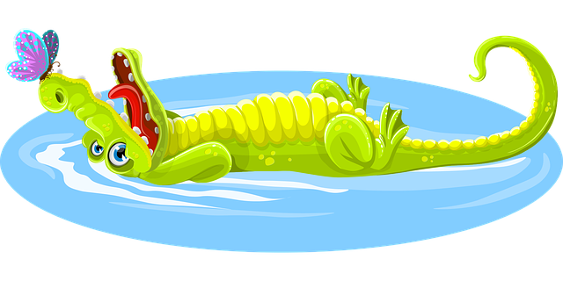

Can you help Ali the Alligator with her alphabet?
Write out the letters and fill in the missing one

a | b | c | d | e

a | b |  | d | e | f

h | i | j |  | l | m

c | d | e | f |  | h

q | r | s |  | u | v

t | u | v | w |  | y

a |  | c |  | e


