WORD BUILDING 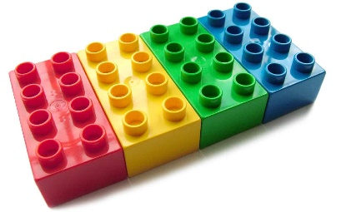

You will need;
7 pieces of card or paper. Write one of these letters on each piece of paper;
i s a t n p c
Now! Can you build the words? Read the clues below…..
A little furry animal that goes miaow ____ ____ ____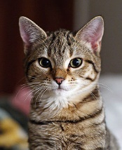

A baby has this if he’s tired  ____ ____ ____
Fizzy drinks come in one of these 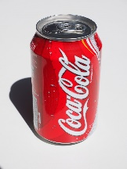 ____ ____ ____
We do this sometimes in school 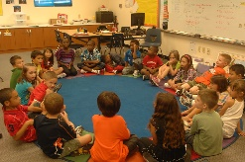 ____ ____ ____

You do this to a dog when he’s good    

