Here is your story for this week! Remember to use your reading strategies if you are stuck!! Look at the picture! Look at the first sound! Think of a word that fits the picture!!

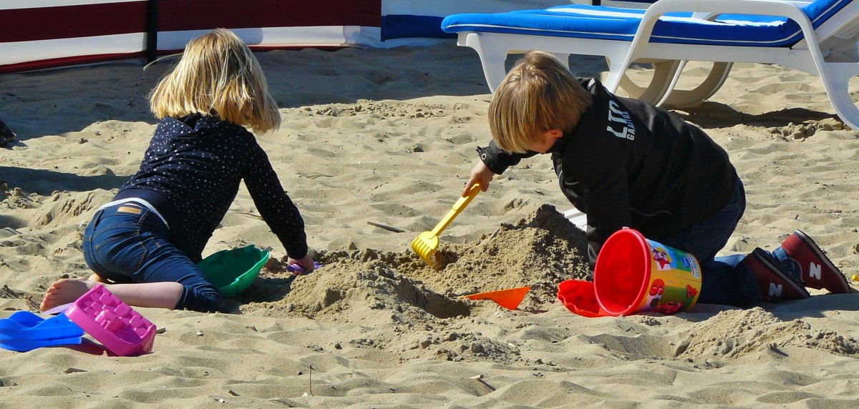

Look at Sam.
Look at Abby.
Sam is digging.
Abby is digging too.
Sam said “I like digging in the sand.”
Abby said “I like digging in the sand too.”
Draw a picture of what you think Sam and Abby built!
Write a sentence from the story under your picture!

