We are learning to improve our memory!!
You are going to look really carefully at this picture for 30 seconds. Look at his hat, his parrot, his sword and lots more! Then look away. How many things can you remember??

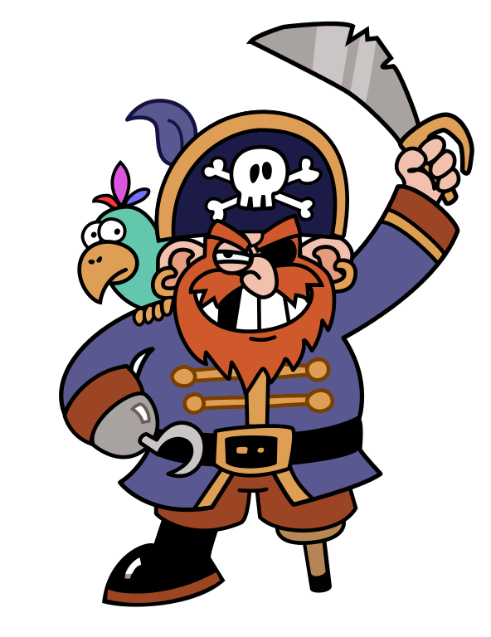

Did you remember 4 things? Or maybe 5? Or even 6??!!
Brilliant work!!

