Read the question below. Write the question down. Is the answer Yes or No? Write the answer beside it!
If you’re stuck on a word, say each sound, then put them back together

1.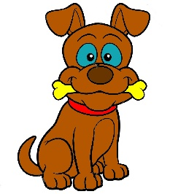 Can a dog run? Yes or No?

2. Can the moon run?? Yes or No?

3.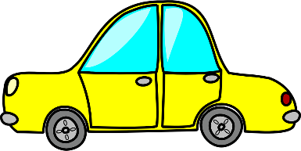 Can a car hop? Yes or No?

4. Is dad a man? Yes or No?

5. Is my flower red? Yes or No?

