You had a game like this last week!
This game will make your memory stronger. 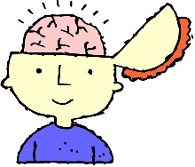
A strong memory will help you remember other things like words and sounds.

Look at these 3 pictures. Say their names out loud in order. Now look away. Can you say them in order? No peeping!!

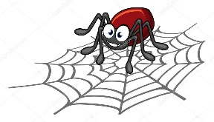 |  | 

This time there are 4 pictures. Look very carefully at them. Say their names out loud. Say them again! Look away. Now try to say them in order!! No peeping!!

 |  | 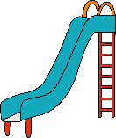 | 

If you didn’t remember them all the first time- don’t worry! Have another really good look. Turn away. Try again!!

