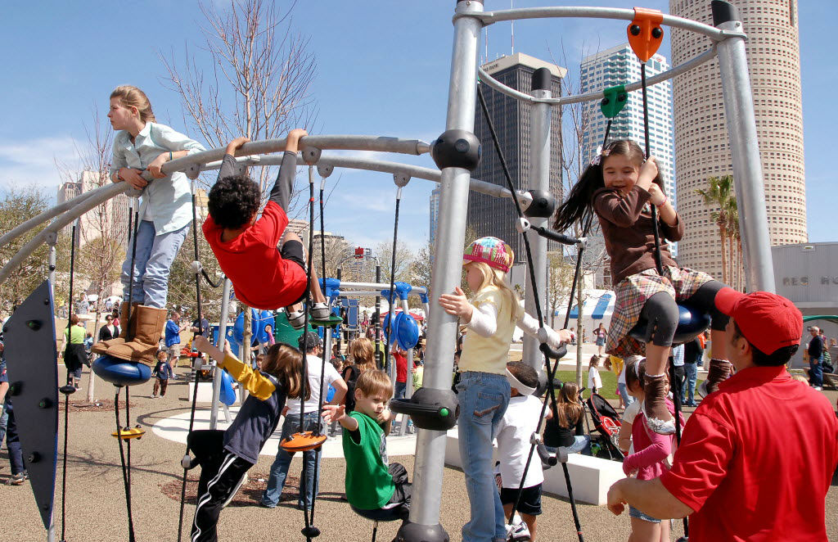
A story for you to read. What can you do if you’re stuck on a word? Remember our Reading Strategies?

Here is a park.
I can see the boys in the park.
I can see the girls in the park.
Can you see Dad?
Dad has a red hat.
The boys and girls are climbing.

What do you like to do in the park? Draw it!! 

