School Sports Day!!

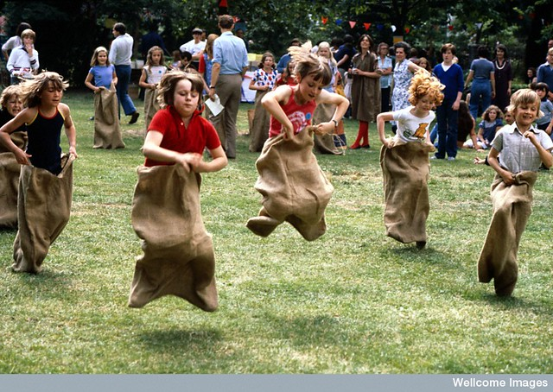
The boys and girls are having a sack race. Can you sort out the sounds below to make a word? All the words have something to do with the sack race!! You could write each sound on a piece of paper and move them about to make the word!The red letter goes first!!

ck | a | s

r | n | u

n | w | i

u | j | p | m

