Here is the last story for P3! Remember what to do if you are stuck on a word? That’s right- say the first sound. Or…look at the picture. Or…think about a word that would make sense!

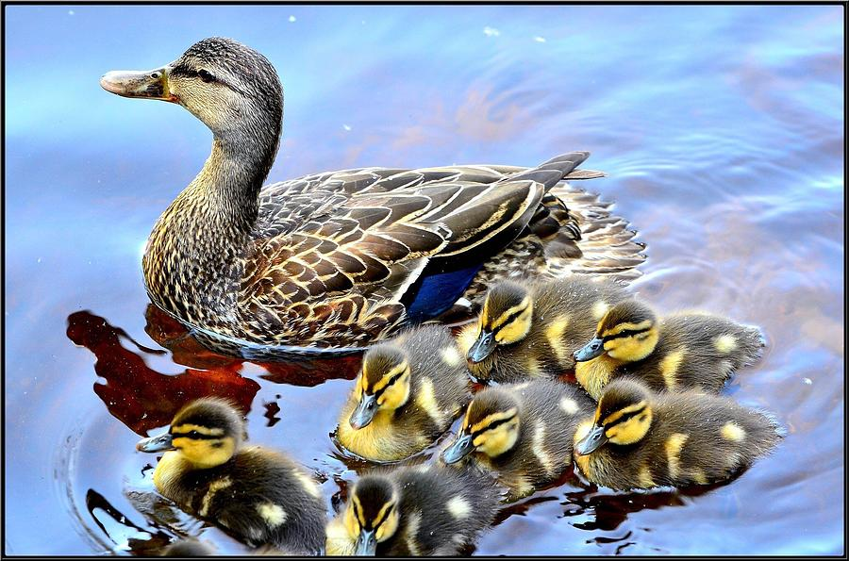

Look at the ducks!
The ducks are in the water.
I can see the mummy duck.
I can see the baby ducks.
The baby ducks are called ducklings.
I can see one, two, three, four, five, six, seven ducklings!

Now draw the mummy duck and her 7 little ducklings. Can you make up a name for one of the ducklings?

