Itchy Bear
Neil Griffiths

The fun has just begun!

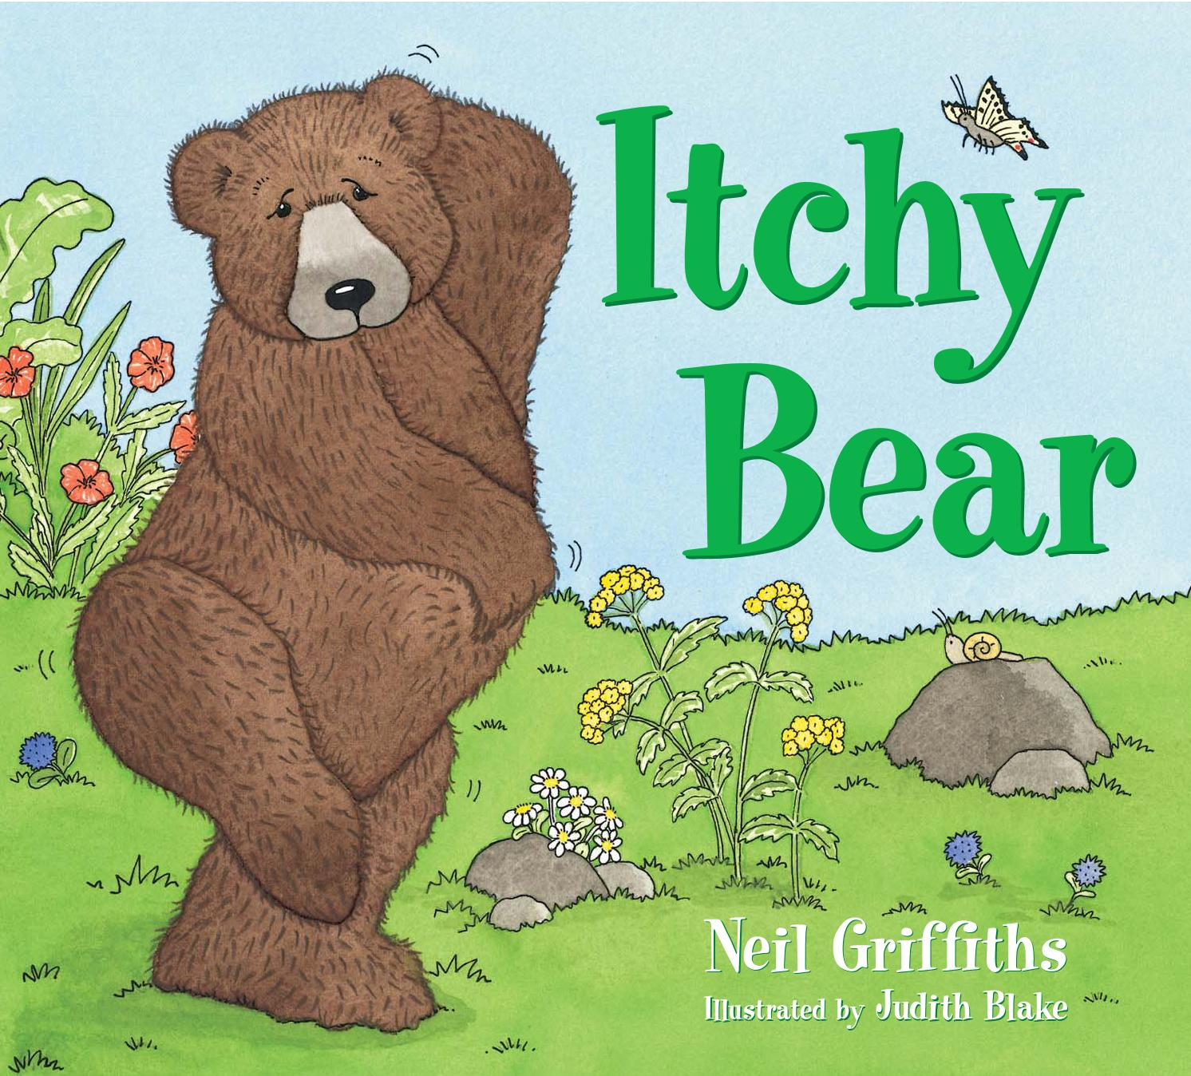

Butterfly puppet

Make your own butterfly puppet.

1 Cut out butterfly and finger loop.
2 Curl finger loop round finger and
stick ends together.
3 Stick finger loop to underside of
butterfly.

Itchy Bear hand puppet
Cut out the front and back of Itchy Bear along the dotted lines and stick together.
Remember to leave an opening at the base for your hand.
I
back
Leave open at base
Finger puppets ITCH 5
Cut out and colour in the finger puppet templates. Fold them in half and stick together, leaving the base open so you can get your finger in.

Use these finger puppets to sequence or retell the story.

Song and dance time

Sing to the tune of Head, shoulders, knees and toes.
Chin and tummy
Chin, tummy,
Ears and toes,
Ears and toes.
Chin, tummy,
Ears and toes,
Ears and toes.
Arm and bottom, knees and eyes,
Chin, tummy,
Ears and toes,
Ears and toes.

Sing to the tune of If you’re happy and you know it.
Repeat for
bottom/rock, tummy/log and toes/twig.
If you’re itchy and you know it!
V1
If you’re itchy and you know it, itch your ears,
If you’re itchy and you know it, itch your ears,
If you’re itchy and you know it, and you really want to show it,
If you’re itchy and you know it, itch your ears.
V2
If you’re itchy and you know it, find a branch,
If you’re itchy and you know it, find a branch,
If you’re itchy and you know it, and you really want to scratch it,
If you’re itchy and you know it, find a branch.

Sing to the tune of Old MacDonald had a farm.
Itchy Bear had an itch!
Itchy Bear, he had an itch and he found a rock.
And on that rock he placed his bottom, ready for a scratch.
With a scratch, scratch here and a scratch, scratch there.
Here a scratch, there a scratch, everywhere a scratch, scratch.
Itchy Bear, he had an itch, but it now has gone!

Snack time ideas
• Eat apples cut into halves and quarters.
• Make butterfly cakes.
• Decorate a digestive biscuit to make it look like a butterfly. Use icing and icing pens or sweets.
• Drink apple juice.
Itchy Bear – Teacher and library staff

I

n Books
ITCH CH 7

ICH

