Probability

Work out the probability of events in each word problem.

- A bag contains five marbles coloured blue, purple, yellow, orange and green. Blake lifts out two marbles, checks the colour, then puts them back. Alex then lifts out two marbles from the bag. What is the probability for each of them, that they both lifted out a purple marble?
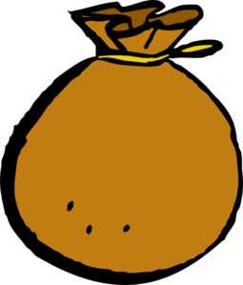

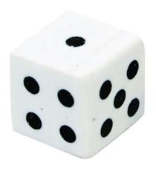
- Nathan rolls a six sided dice four times. What is the probability that each throw was an even number?

- Alexis is writing out a list of numbers from 1-10 in a random order.

  - What is the probability that seven is her first number?

  - What is the probability that she chooses an odd number first?

- List all the numbers this spinning top can show when it lands after spinning

  - A number less than 10
9
14
11
12
6
4
  - An even number
  - A factor of 42
  - A multiple of 3
  - A square number
  - A factor of 36
  - A cubed number

Answers
- There is one purple marble in the bag, so no matter how many marbles are pulled out each child only has a 1 in 5 or ⅕ or 20% chance that one of the two marbles pulled out will be purple.

- There are 3 even numbers on a dice 2, 4, 6. Each throw would mean 1 out of 2 chances that it would be an even number (or ½ or 50%). If Nathan threw the dice four times that would mean that it is now out of 6 x 4 options, 6 sides, 4 throws = 24, but there are still half of the numbers odd and half of the numbers even, so the answer is that the probability that Nathan would throw an even number is 12 out of 24 or ½ or 50%. It stays the same.

- a. If there are 10 cards, numbered 1 to 10 then there is only one number 7 card. So there is only 1 chance out of 10 that the card pulled out is a 7. Answer = 1 out of 10 or 1/10.

b. For the probability of choosing an odd number, you need to see how many odd numbers are there; 1, 3, 5, 7, 9 – five odd numbers altogether. So the probability of pulling out an odd number is 5 out of 10 or 5/10 or 1 out of every 2 or ½ or 50%. They all mean the same thing.

- 6 options on the spinning top 4, 6, 9, 11, 12, 14
  - There are 3 numbers under 10 and 3 numbers over 10 so the answer is 3 out of 6, which means the same as 1 out of every 2 spun or 50% or ½.
  - Four of the six numbers are even numbers; 4, 6, 12, 14. So that means that for every spin there is a 4 out of 6 chance that they will spin an even number. A simpler way to write that is 2 out of 3 chances, ⅔ or 66⅔%.
  - When you think of factors or 42 you need to think of multiples in pairs. If you start with the tables that you know the factors are; 1 and 42, 2 and 21, 3 and 14, 4 doesn’t divide evenly so it’s not one, nor is 5, 6 and 7 times together to make 42, 8,9 and 10 don’t divide evenly so they aren’t factors. So we are looking at 1, 2, 3, 6, 7, 14, 21, 42. Which of those numbers are on the spinner? 6 and 14. Your answer is then going to be 2 out of 6 options or to simplify 1 out of every three spins, ⅓, or 33⅓% chance to score a factor of 42.
  - For a multiple of 3 you need to look at each of the numbers and see if 3 divides evenly into that number. Using our tables knowledge to help us we know that 6, 9 and 12 can be divided evenly by 3. 4, 11 and 14 can’t so they are not options. Your answer then is that you have a 3 out of 6 chance or simplified a 1 out of 2 chance, ½ or 50% chance of getting a multiple of 3.
  - A square number is the answer when a number is multiplied by itself; for example, 2 x 2 = 4, 3 x 3 = 9, 4 x 4 = 16, 5 x 5 = 25 and so on. Look at the numbers on the spinner 4, 6, 9, 11, 12, 14. We know that there aren’t many square numbers; 4, 9, 16, 25, 36, 49, 64, 81, 100, etc. Our answer is how many of the numbers match up – 4 and 9 so 2 out of 6 options. The same probability as for c.
  - Cubed numbers 2x2x2=8, 3x3x3=27, 4x4x4=64. There aren’t any cubed numbers on the spinner so 0 out of 6 is the answer.

