Probability Scales

1  2  3  4  5 | 0  1  A C B D  a) Label the probability of an even number A.  b) Label the probability of a number greater than 1 with B.  c) Label the probability of a number less than 4 with C.  d) Label the probability of a number less than 6 with a D.
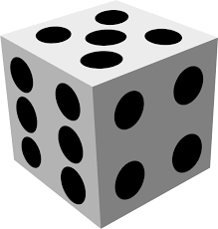 | 0  1  A D B C  a) Label the probability of a 3 with A.  b) Label the probability of a number greater than 2 with B.  c) Label the probability of a number less than 7 with C.  d) Label the probability of a number less than 3 with a D.
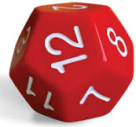 | 0  1  C B A  D  a) Label the probability of an odd number A.  b) Label the probability of a number less than 5 with B.  c) Label the probability of a number greater than 9 with C.  d) Label the probability of a multiple of 3 with a D.
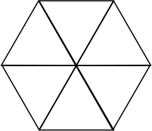  3  2  1  4  5  0 | 0  1  A B D C  a) Label the probability of a number less than 2 A.  b) Label the probability of a number which is odd with B.  c) Label the probability of a number less than 6 with C.  d) Label the probability of a number greater than 1 with a D.
4  3  2  1  2  5  5  4 | 0D  1  A C B  a) Label the probability of a 2 with A.  b) Label the probability of a number less than 4 with B.  c) Label the probability of a number which is odd with C.  d) Label the probability of a number greater than 5 with a D.
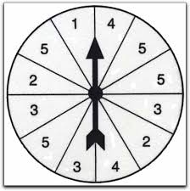 | 0  1  C B A D  a) Label the probability of an even number A.  b) Label the probability of a number less than 3 with B.  c) Label the probability of a number greater than 5 with a C.  d) Label the probability of a number which is a factor of 10 with D.
Probability Scales

1  2  3  4  5 | 0  1  a) Label the probability of an even number A.  b) Label the probability of a number greater than 1 with B.  c) Label the probability of a number less than 4 with C.  d) Label the probability of a number less than 6 with a D.
0
1

a) Label the probability of a 3 with A.
b) Label the probability of a number greater than 2 with B.
c) Label the probability of a number less than 7 with C.
d) Label the probability of a number less than 3 with a D.

0
1

a) Label the probability of an odd number A.
b) Label the probability of a number less than 5 with B.
c) Label the probability of a number greater than 9 with C.
d) Label the probability of a multiple of 3 with a D.

3  2  1  4  5  0 | 0  1  a) Label the probability of a number less than 2 A.  b) Label the probability of a number which is odd with B.  c) Label the probability of a number less than 6 with C.  d) Label the probability of a number greater than 1 with a D.
4  3  2  1  2  5  5  4 | a) Label the probability of a 2 with A.  b) Label the probability of a number less than 4 with B.  c) Label the probability of a number which is odd with C.  d) Label the probability of a number greater than 5 with a D.
  0
  1
0
1

a) Label the probability of an even number A.
b) Label the probability of a number less than 3 with B.
c) Label the probability of a number greater than 5 with a C.
d) Label the probability of a number which is a factor of 10 with D.

